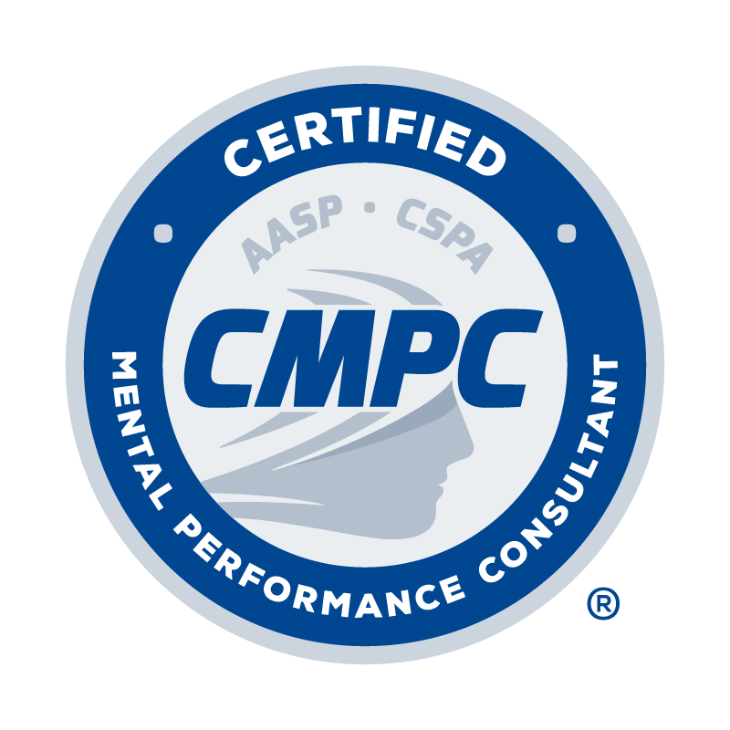
ALL SECTIONS OF THIS FORM MUST BE TYPED

Complete the Record of Mentored Experience Hours Form by following the instructions provided. Documentation and verification of a 400-hour mentored experience is required. The 400-hour mentored experience consists of a minimum of 200 hours spent in direct client contact, a maximum of 150 hours spent in support activities, and a minimum of 50 hours spent in mentorship (i.e., face-to-face mentorship, electronic mentorship, and direct knowledge of services). A minimum of 200 hours across these categories must be with competitive sport populations. See the instructional page for complete descriptions of these categories and specific hour requirements. Mentored experiences can be completed during the applicant’s graduate education or as a post-graduate experience. Each mentor listed on the Record of Mentored Experience Hours Form must complete a Mentorship Verification Form. This form can be downloaded from the Mentored Experience step in Certemy.

Mentor Approval: Mentors for the mentored experience must be approved by the Certification Council. All Certified Mental Performance Consultants who document the completion of required continuing education in mentorship/ supervision are listed in the Registry of Approved Mentors and approved to provide mentorship. Non-certified mentors can be approved for listing by submitting the Registry of Approved Mentors Application Form. They can maintain their listing by completing required continuing education in mentorship/supervision and other professional practice areas. It is the applicant’s responsibility to ensure that mentors for their mentored experience are approved by the Certification Council. Applicants are encouraged to confirm that mentors are approved before beginning their mentored experience and maintain approval throughout to avoid the risk of the accumulated hours not being eligible to be counted.

Eligible Activities: Only time spent in direct client contact, support activities, and mentorship in an applied sport/performance psychology setting are eligible to be counted toward the mentored experience hours. If in doubt, please provide detailed information and/or contact the Chair of the Certification Council for clarification. Examples of activities that are considered eligible and ineligible for the required mentored experience include but are not limited to:

Examples of eligible activities:

- Working with individual athletes, performing artists, military personnel, and other relevant performers on performance-related issues (e.g., motivation, confidence, performance anxiety, arousal control, injury rehabilitation).
- Consulting directly with an athletic or performance team and teaching mental skills such as goal-setting, relaxation/activation, concentration, imagery, self-talk, and performance routines.
- Consulting with an administrator (e.g., athletic director, general manager) about how to effectively incorporate mental skills development programs into operating routines of the particular organization
- Serving as a youth sports organization consultant educating parents, athletes, and/or coaches about healthy competition patterns, moral reasoning, and life skills.
- Working as an academic counselor and providing formal training (e.g., stress management, problem-solving, goal setting, time management) to athletes related to performance enhancement.
- Working as an intern in a corporation and providing exercise intervention programs to improve the psychological well-being of employees.

Example of ineligible activities:

- Serving as a team’s athletic coach, athletic trainer, or strength coach.
- Working in an alcohol rehabilitation center that happens to have athletes or other performers as clients.
- Providing marital and family counseling to athletes, dancers, or soldiers and their families.
- Contracting with professional sports teams to do a psychometric work-up of players to make a psychological diagnosis.
- Being part of a general counseling practice treating an athlete or other performer for an eating disorder.
- While completing an internship in psychology, prescribing running as part of clinical therapy.
- While serving as an academic counselor, providing academic support services to athletes.
- As an intern hired by a corporation you use performance enhancement interventions to address mental health issues of their employees.

Instructions for Completing the Record of Mentored Experience Hours Form

1. Dates of Service: List the starting and ending month/year related to time spent in the sport or activity.

2. Name of Mentor: List the name of your mentor who provided mentorship related to time spent in the sport or activity.

3. Level/Setting of Sport or Activity: Specify the type of sport or activity in which time was spent along with the level of participants. For example: college baseball team, recreational marathon runner, junior high school wrestler, basic training military unit, professional musician. A minimum of 200 hours (direct client contact + support activities + mentorship) of the 400 total hours must be spent with competitive sport populations. The remaining 200 hours can be spent with sport or non-sport (e.g., exercisers, performing artists, military service organizations, high-risk occupations) populations.

4. Hours Spent in Direct Client Contact: Record the number of hours spent in in-person contact with individuals (e.g., athlete, coach, exerciser, performing artist, soldier) or groups (e.g., sport team, coaching staff, fitness class, dance troupe, military unit) working on mental skills to optimize performance, involvement, enjoyment, and/or personal development. Activities include individual consultation, group facilitation and consultation, psychoeducational workshops, and team-building exercises. A minimum of 200 of the 400 total hours must be spent in direct client contact.

5. Hours Spent in Support Activities: Record the hours spent in activities that pertain to individual or group clients but do not involve direct client contact. Activities include onsite observation of individual or group clients, record keeping and report writing, reviewing case notes or video/audio recordings, researching and preparing materials for intervention sessions, assessment scoring and interpretation, and case management (e.g., referral, consultation with other professionals). A maximum of 150 of the 400 total hours can be spent in support activities.

6. Mentorship Hours Spent in:
a. Face-to-Face Mentorship: Record the hours spent meeting with your mentor either in-person or from a distance via synchronous video and audio technology (e.g., Zoom, Skype, FaceTime) that approximates in-person contact (e.g., mentor and mentee can attend to verbal and non-verbal behavior).
b. Electronic Mentorship: Record the hours spent communicating with your mentor in a manner that does NOT meet the definition of face-to-face mentorship above (e.g., telephone, email, texting).

At least 40 of the required 50 mentorship hours must be spent in face-to-face and/or electronic mentorship. A minimum of 30 of these 40 hours must be spent in face-to-face mentorship, and the remaining 10 of these 40 hours can be spent in either face-to-face or electronic mentorship. No mentorship hours should be recorded without Direct Client Contact.

7. Hours of Direct Knowledge of Services: Record the hours your mentor observed your skills and provision of services via samples of your work using modalities such as onsite observation, audio or video recordings, live streaming, test and questionnaire protocols, client homework, and/or other client-generated materials. For novice mentees (see definition provided in Candidate Handbook), a minimum of 10 hours of audio recording, video recording, or live observation onsite or via distance video technology must be recorded on the form. For advanced mentees (see definition provided in Candidate Handbook), a minimum of 10 hours of samples provided to the mentor using an acceptable combination of the modalities listed above based on the mentor’s judgment must be recorded on the form. While more direct knowledge of service hours can be accumulated, only 10 hours can be counted toward the required 50 mentorship hours.

8. Skills Employed During Interventions: Record the types of skills or interventions used with individuals or groups. For example: goal setting, relaxation training, attentional focus, imagery, team building, relationship-building, etc.

If additional entry space is needed, use the second Record of Mentored Experience Hours Form below. If you have more than one mentor and are using both forms, organize your hours so all hours with each mentor are on their respective form as much as possible.
RECORD OF MENTORED EXPERIENCE HOURS FORM
(See instructional page for guidelines in completing this form)

The Record of Mentored Experience Hours Form should be completed before the Mentor Verification Forms. First, complete this Hours Form with all documented hours and then send this with the Mentor Verification Forms to your approved mentor(s) for sign-off.

Dates of Service | Name of Mentor | Level / Setting of Sport or Activity | Hours Spent in  Direct Client Contact |  | Hours Spent in Support Activities | Mentorship Hours |  |  | Total Hours Spent in this Sport / Activity | Hours of Direct Knowledge of Services | Skills Employed During Interventions with Individuals and/or Groups
 |  |  | In Person | Virtual |  | Face-to-face (Zoom, Skype, FaceTime, In-Person) | Group | Electronic (Phone Calls, Email, Text)
01/2023 to 01/2024 | Dr. Sport Psych | College baseball team | 20.00 | 0.00 | 15.00 | 3.00 | 0.00 | 1.00 | 39.00 | 1.00 | Goal setting, attentional focus, negative thought stopping, team building
 |  |  |  |  |  |  |  |  | 0.00
 |  |  |  |  |  |  |  |  | 0.00
 |  |  |  |  |  |  |  |  | 0.00
 |  |  |  |  |  |  |  |  | 0.00
 |  |  |  |  |  |  |  |  | 0.00
 |  |  |  |  |  |  |  |  | 0.00
 |  |  |  |  |  |  |  |  | 0.00
 |  |  |  |  |  |  |  |  | 0.00
 |  |  |  |  |  |  |  |  | 0.00
 |  |  |  |  |  |  |  |  | 0.00
 |  |  |  |  |  |  |  |  | 0.00
 |  |  |  |  |  |  |  |  | 0.00
 |  |  |  |  |  |  |  |  | 0.00
 |  |  |  |  |  |  |  |  | 0.00
 |  |  |  |  |  |  |  |  | 0.00
 |  |  |  |  |  |  |  |  | 0.00
 |  |  |  |  |  |  |  |  | 0.00
 |  |  |  |  |  |  |  |  | 0.00
 |  |  | 0.00 | 0.00 | 0.00 | 0.00 | 0.00 | 0.00 | 0.00 | 0.00 | 0.00 Total Hours

Dates of Service | Name of Mentor | Level / Setting of Sport or Activity | Hours Spent in  Direct Client Contact |  | Hours Spent in Support Activities | Mentorship Hours |  |  | Total Hours Spent in this Sport / Activity | Hours of Direct Knowledge of Services | Skills Employed During Interventions with Individuals and/or Groups
 |  |  | In Person | Virtual |  | Face-to-face (Zoom, Skype, FaceTime, In-Person) | Group | Electronic (Phone Calls, Email, Text)
01/2023 to 01/2024 | Dr. Sport Psych | College baseball team | 20.00 | 0.00 | 15.00 | 3.00 | 0.00 | 1.00 | 39.00 | 1.00 | Goal setting, attentional focus, negative thought stopping, team building
 |  |  |  |  |  |  |  |  | 0.00
 |  |  |  |  |  |  |  |  | 0.00
 |  |  |  |  |  |  |  |  | 0.00
 |  |  |  |  |  |  |  |  | 0.00
 |  |  |  |  |  |  |  |  | 0.00
 |  |  |  |  |  |  |  |  | 0.00
 |  |  |  |  |  |  |  |  | 0.00
 |  |  |  |  |  |  |  |  | 0.00
 |  |  |  |  |  |  |  |  | 0.00
 |  |  |  |  |  |  |  |  | 0.00
 |  |  |  |  |  |  |  |  | 0.00
 |  |  |  |  |  |  |  |  | 0.00
 |  |  |  |  |  |  |  |  | 0.00
 |  |  |  |  |  |  |  |  | 0.00
 |  |  |  |  |  |  |  |  | 0.00
 |  |  |  |  |  |  |  |  | 0.00
 |  |  |  |  |  |  |  |  | 0.00
 |  |  |  |  |  |  |  |  | 0.00
 |  |  | 0.00 | 0.00 | 0.00 | 0.00 | 0.00 | 0.00 | 0.00 | 0.00 | 0.00 Total Hours

